This service is for PICYS young people experiencing Alcohol and Other Drug (AOD) issues and homelessness. PICYS’ DESS (Drug Education Support Service) worker can support young people to address their AOD issues in a safe and supported environment. They do this with PICYS young people one-to-one at PICYS, as outreach, and also through co-facilitating The SESH and other PICYS drop in and groups sessions.

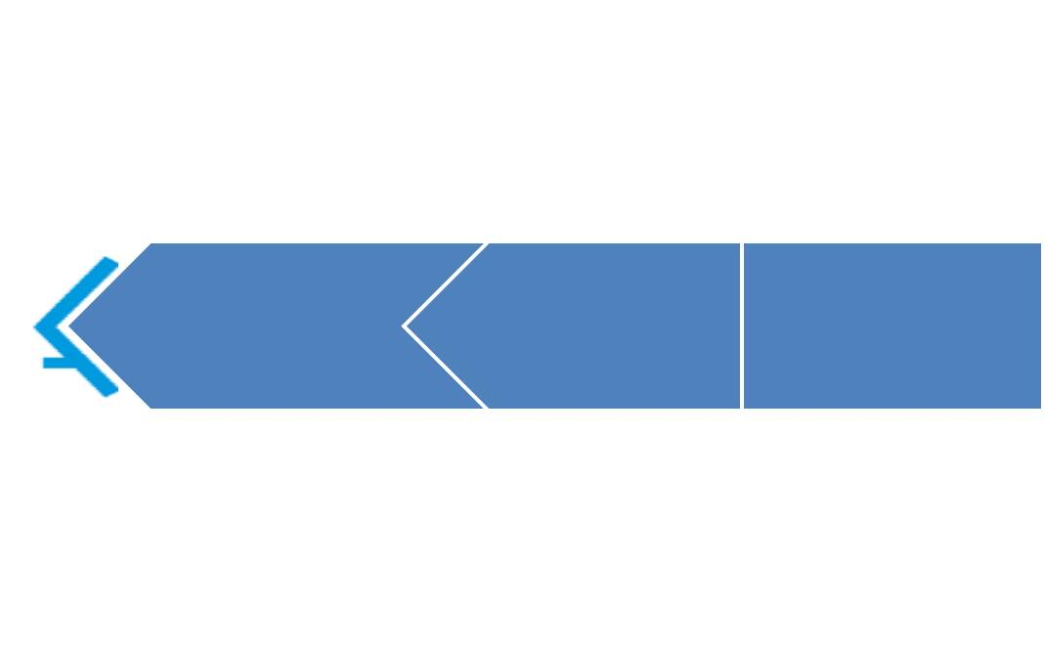

**DESS**

**Drug Education Support Worker will:**

* provide support for young people with AOD struggles to monitor, manage and/or reduce use and work on harm minimisation
* support young people with relapse prevention strategies
* support young people to start and/or maintain engagement with specialist AOD counselling
* provide education about AOD use and harm reduction
* be grounded in a trauma informed and relationship-based approach
* promote personal recovery
* recognise co-occurring AOD use and mental health issues
* focus on whole of life and quality of life needs, taking a holistic approach

**…as defined by the young person.**

**For a young person to be eligible for individualised support with the DESS program, they need to be:**

* Aged between 16-25
* Be actively engaged in a Support Plan with a Household Network or PILLAR Youth Worker
* Current drug and/or alcohol issues

**The SESH (Substance use Education Support and Harm minimization)**

The Substance use Education Support and Harm minimisation (SESH) group is an alcohol and other drugs education, support, and harm minimisation group. The group meets every fortnight on Wednesdays from 1-2 pm and is open to anyone aged 15-25 (maximum of 8 people per week). Topics vary but may include opioids, cannabis, relapse prevention, and more.

Access to SESH:

Primarily for young people engaged in HHN & PILLAR: The SESH group was initially intended for young people involved in the HHN & PILLAR programs. However, it may also be open to other young people aged 15-25.

Access to DESS worker:

Young people can also access DESS worker during their rostered Base Camp drop-in sessions. DESS worker can support YP informally during Base Camp and provide harm minimisation and advice regarding AOD use.

**Contact us**

|  |
| --- |
| PICYS DESS Worker  **Drug Education Support Service**  22 Blencowe Street  West Leederville WA 6007  PO Box 1062  West Leederville WA 6901  Phone: (08) 9380 4660  e-mail: info@picys.org.au  Office Hours : Mon - Fri 9:00 – 5pm  **www.PICYS.org.au** |